**Sean Poston**

**CS351 Homework 9**

**Question 6:**

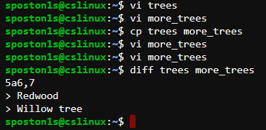

The cp command is useful because it copies one file to another. After adding the last two lines of “redwood” and “willow tree” to more_trees, we can use the diff command to output the difference in the two files.

**Question 10:**

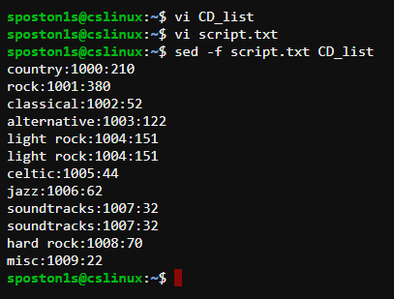

script.txt:

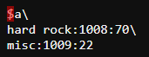

The sed command is a very versatile tool that can be used to edit large files with find and replace or inserting spaces between each line and much more.

**Question 11:**

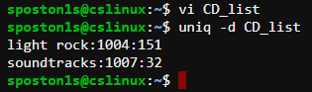

The uniq command “removes duplicate lines to create unique output.” This is coupled with the -d option to only output one copy of each line that has a duplicate.